Lab Sheet 2:
Implement algorithm as user-defined functions

- Write a program to draw a circle using Midpoint circle algorithm.
- Write a program to draw a hemisphere as follows using midpoint circle generation.
(Hint: only 1st and 4th quadrants)
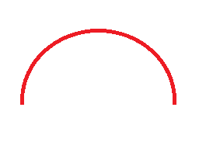

- Write a program to draw a hemisphere as follows using midpoint circle generation.
(Hint: only 1st and 2nd quadrants)

- Write a program to draw sector as follows using midpoint circle generation.
(Hint: only 2nd and 6th octants)
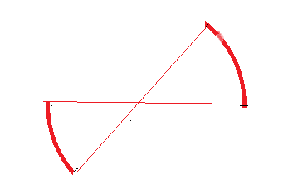
- Write a program to draw sector as follows using midpoint circle generation.
(Hint: exclude 4th quadrant)
